**DAY ONE**

Inception of Open Source EDA, OpenLANE and Sky130 PDK

Tasks: Running ‘picorv32a’ synthesis using OpenLane flow and generating necessary outputs.

Screenshots of running commands for synthesis:

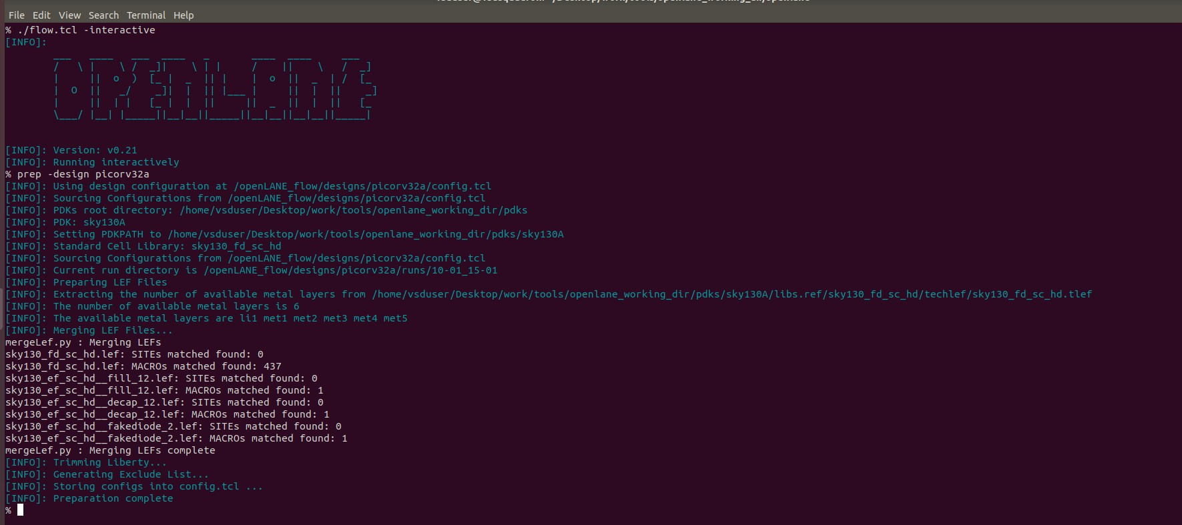

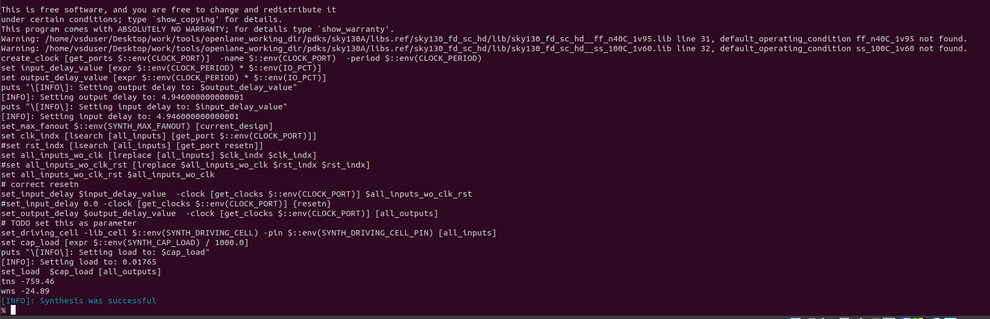

Screenshots of synthesis statistics report file:

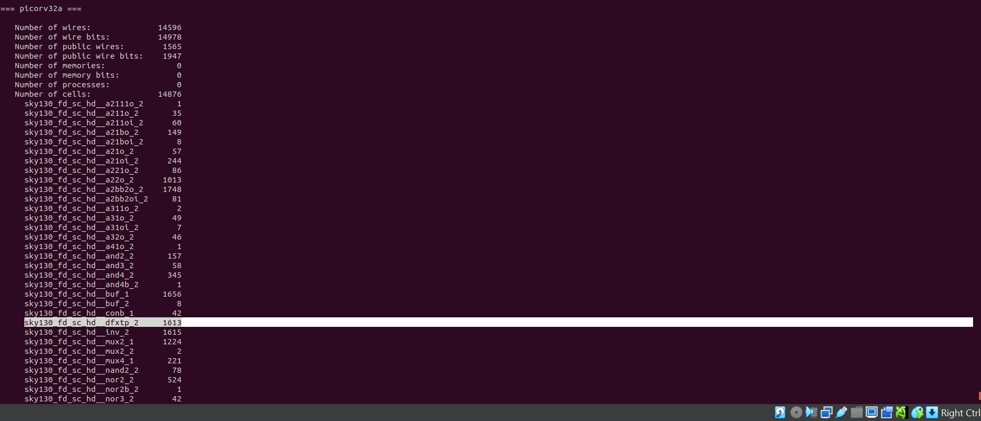

Calculation of Flop Ratio and DFF%:

*Flop Ratio = Number of D Flip Flops*

*Total number of cells*

= 1613 / 14876

= 0.108429

*Percentage of D-FF’s = Flop Ratio x 100 %*

= 0.108429 x 100 %

= 10.8429 %